A

Technical Seminar On

**“NATURAL LANGUAGE PROCESSING FOR ADAPTIVE DIALOGUE**

**SYSTEM”**

Submitted to JNTUH in partial fulfillment of the

Requirements for the award of the Degree of

**BACHELOR OF TECHNOLOGY**

In

**COMPUTER SCIENCE & ENGINEERING**

By

**PURAM RAJA VENKATA SHANDILYA 20N61A0582**

Under the Guidance of

**Mrs. E. SHASHI REKHA**

**Assistant Professor**

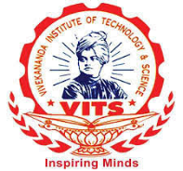

**DEPARTMENT OF COMPUTER SCIENCE**

**VIVEKANANDA INSTITUTE OF TECHNOLOGY & SCIENCE**

(Approved by AICTE New Delhi & Affiliated to JNTU, Hyderabad)

**An ISO 9001:2015 Certified Institution**

**Karimnagar-505501**

**2020-2024**

**VIVEKANANDA INSTITUTE OF TECHNOLOGY & SCIENCE**

(Approved by AICTE New Delhi & Affiliated to JNTU, Hyderabad)

**An ISO 9001:2015 Certified Institution**

**Karimnagar-505501**

**DEPARTMENT OF COMPUTER SCIENCE AND ENGINEERING**

**CERTIFICATE**



This is to certify that the technical seminar report titled **NATURAL LANGUAGE PROCESSING FOR ADAPTIVE DIALOGUE SYSTEM** is being submitted by **PURAM RAJA VENKATA SHANDILYA** bearing **20N61A0582** in B.Tech IV-I semester, Computer Science & Engineering is a record bonafide work carried out by him.

**Internal Guide Head of the Department**

**Mrs. E. Shashi Rekha Dr. Mula Veera Hanumantha Reddy**

**Co-Ordinator** **Principal**

**Mrs. B. Sirisha Dr. Dabbu Murali**

**VIVEKANANDA INSTITUTE OF TECHNOLOGY & SCIENCE**

(Approved by AICTE New Delhi & Affiliated to JNTU, Hyderabad)

**An ISO 9001:2015 Certified Institution**

**KARIMNAGAR-505501**

**DEPARTMENT OF COMPUTER SCIENCE AND ENGINEERING**

**DECLARATION**



I **PURAM RAJA VENKATA SHANDILYA**, bearing Hall ticket no **20N61A0582** here by declare that the technical report entitled **NATURAL LANGUAGE PROCESSING FOR ADAPTIVE DIALOGUE SYSTEM** submitted in partial fulfillment of the requirements for the award of degree in

B. Tech IV-I semester, Computer Science & Engineering. This is a record bonafide work carried out by me. The results embodied in this report have not been submitted to any other University for the award of any degree or diploma.

PURAM RAJA VENKATA SHANDILYA

HTNO: 20N61A0582

DEPARTMENT OF COMPUTER SCIENCE AND ENGINEERING

VIVEKANANDA INSTITUTE OF TECHNOLOGY & SCIENCE, Karimnagar.

**ACKNOWLEDGEMENT**

We are profoundly grateful to express our deep sense of gratitude and respect towards our guide **Mrs. E. SHASHI REKHA Assistant Professor, Department of Computer Science and Engineering. VIVEKANANDA INSTITUTE OF TECHNOLOGY &** **SCIENCE, KARIMNAGAR**, for her excellent guidance right from selection of the Technical Seminar and his valuable suggestion throughout the Technical Seminar. We are thankful to her for giving us the opportunity to work in the laboratory at any time. Her constant encouragement and support have been the cause for us to succeed, in completing this in the college. She has given us a tremendous support both technical and moral front.

We are thankful to **Dr. M.V. HANUMANTHA REDDY**, HOD CSE, and Technical Seminar Review Committee members for their valuable suggestions and support in completion of the Technical Seminar.

We are thankful to **Dr. DABBU MURALI**, Principal, **VIVEKANANDA INSTITUTE OF** **TECHNOLOGY & SCIENCE** for the support during and till the completion of the Technical Seminar.

We extend our thanks to the College Management for their support and encouragement for the success of our Technical Seminar.

**CONTENT**

1. INTRODUCTION
2. ABSTRACT
3. DOMAIN
4. PROBLEM STATEMENT
5. SOLUTION
6. EXISTING SYSTEM
7. WORK FLOW OF NLP
8. PROPOSED WORK
9. PROPOSED METHODOLOGY
10. DIFFERENCES BETWEEN NLP AND NLP WITH ADS
11. APPLICATIONS OF NLP WITH ADS
12. LIMITATIONS
13. FUTURE SCOPE
14. CONCLUSION
15. REFERENCES

**INTRODUCTION**

In the ever-evolving landscape of artificial intelligence, the fusion of Natural Language Processing (NLP) with Adaptive Dialogue Systems marks a significant leap toward enhancing the way machines comprehend and engage with human language. This synergy not only transcends the traditional boundaries of human-computer interaction but also propels us into an era where machines can dynamically adapt their responses, mirroring the nuanced fluidity of human conversation.

At its essence, NLP encapsulates the ambition to decode the intricacies of language, enabling machines to interpret, understand, and generate human-like text or speech. As technology progresses, the focus has shifted from static conversational agents to Adaptive Dialogue Systems, where responsiveness is dynamically tailored based on user inputs, contextual cues, and the evolving nature of the discourse.

The core challenge lies in Natural Language Understanding (NLU), where machines strive to grasp the subtle nuances, sentiments, and intentions embedded within human language. It is here that sophisticated algorithms, deep learning models, and semantic analysis converge to unravel the layers of meaning in linguistic expressions, paving the way for more profound and meaningful interactions.

Adaptive dialogue systems go beyond mere recognition, maintaining a continuous awareness of the ongoing conversation. This contextual understanding ensures that responses remain not only accurate but also contextually relevant, fostering a more natural and engaging dialogue between humans and machines.

This report explores how NLP with Adaptive Dialogue Systems employs dynamic learning to adapt over time, addressing user preferences and linguistics, its implications extend across customer service, virtual assistance, and diverse domains. The report unravels the technology's layers, covering challenges, advancements, and its promising future.

.

**ABSTRACT**

Natural Language Processing (NLP) integrated with Adaptive Dialogue Systems (ADS) represents a formidable synergy at the forefront of artificial intelligence. This confluence addresses the increasing prevalence of computer interactions, where the adaptive nature of dialogue systems becomes crucial. NLP, a cornerstone in this alliance, enables machines to comprehend and respond to human language, while ADS takes this a step further by dynamically adjusting responses based on user inputs and evolving conversational contexts. The amalgamation of these technologies holds significant promise in enhancing the efficiency and naturalness of human-computer interactions across diverse applications.

The core objective of this abstract is to unravel the intricacies of NLP with ADS, emphasizing its transformative potential. Adaptive systems, an active research domain, play a pivotal role in shaping the usability of dialogue systems by continually learning from user interactions. This paper delves into the dynamic learning mechanisms employed by ADS, exploring how they adapt to user preferences, linguistic subtleties, and changing conversational patterns. By investigating various techniques, this work contributes to a comprehensive understanding of the design and implementation of adaptive dialogue systems, shedding light on their challenges, advancements, and the promising future they hold in reshaping the landscape of human-machine interaction.

**DOMAIN**

The topic of Natural Language Processing (NLP) with Adaptive Dialogue Systems falls within the domain of Artificial Intelligence (AI) and Human-Computer Interaction (HCI). This interdisciplinary field combines elements of computer science, linguistics, and cognitive psychology to enable machines to understand, interpret, and respond to human language in a way that mimics natural conversation.

In the realm of Artificial Intelligence (AI), the integration of Natural Language Processing (NLP) with Adaptive Dialogue Systems (ADS) represents a captivating frontier. This interdisciplinary field sits at the intersection of computer science, linguistics, and cognitive psychology, aiming to bridge the communication gap between humans and machines.

The significance of NLP with ADS becomes apparent in its applications across various domains within Artificial Intelligence. From machine translation and sentiment analysis to virtual assistants and customer service chatbots, these systems have the potential to revolutionize the way humans interact with intelligent machines.

**PROBLEM STATEMENT**

Bridging the divide between human communication and machine understanding poses a central challenge in Natural Language Processing (NLP). Despite considerable advancements, capturing the intricate nuances of language—context, intent, and sentiment—remains a formidable task. The inherent variability and ambiguity in human expression create hurdles for traditional computational models. The crux of the issue lies in crafting NLP systems that not only precisely interpret linguistic subtleties but also dynamically adapt to the evolving context and fluid dynamics of human conversation. The challenge is to develop systems that navigate the complexities of language with adaptability, enhancing the naturalness of human-machine interactions.

**SOLUTION**

A fundamental solution to the challenge in Natural Language Processing (NLP) involves the implementation of dynamic response mechanisms with Adaptive Dialogue Systems (ADS). These systems, equipped with machine learning algorithms, can dynamically adjust their responses based on user inputs, thereby addressing the evolving context and dynamics of human conversation. By incorporating adaptive elements, such as intent recognition and sentiment analysis, ADS ensures that responses remain contextually relevant and align with the intricacies of user communication.

Adaptive Dialogue Systems can be enhanced through the integration of contextual memory and learning mechanisms. By capturing and retaining information from previous interactions, these systems develop an understanding of user preferences and the evolving context of the conversation. Contextual memory allows the system to maintain coherence in dialogue, ensuring that responses are not only contextually appropriate but also personalized based on the user's history. This approach leverages user context as a valuable resource, contributing to more natural and effective communication.

Another effective solution involves adopting a user-centric design philosophy and incorporating feedback loops. Adaptive Dialogue Systems benefit from understanding user preferences and adapting to individual communication styles. By actively seeking and incorporating user feedback, these systems can continuously learn and refine their responses. This iterative learning process contributes to the system's ability to adapt to the intricacies of human expression, fostering a more intuitive and satisfying user experience. User-centric design, coupled with continuous feedback loops, forms a robust strategy for developing adaptive dialogue systems that bridge the gap between human communication and machine understanding.

**EXISTING SYSTEM**

Before the advent of advanced Natural Language Processing (NLP) with Adaptive Dialogue Systems, traditional conversational agents and static NLP models were prevalent. These systems often relied on predefined rules and patterns, lacking the adaptability to dynamically adjust responses based on evolving user interactions and contexts. Early chatbots and virtual assistants were limited in their ability to understand complex language nuances, context shifts, and user preferences.

Conventional NLP systems, while capable of basic language understanding, struggled with the variability and ambiguity inherent in human communication. These systems operated on fixed algorithms and predefined decision trees, resulting in responses that could feel rigid and disconnected from the natural flow of conversation. The lack of adaptability in these earlier systems posed challenges in meeting the diverse and dynamic needs of users.

As technology progressed, there was a recognition of the limitations in traditional conversational agents, leading to the evolution of Adaptive Dialogue Systems. The shift towards dynamic, context-aware models marked a departure from the static nature of previous systems, addressing the shortcomings of early NLP implementations. These advancements paved the way for more sophisticated and responsive human-machine interactions, reflecting a significant improvement over the previous existing systems.

**WORK FLOW OF NLP**

The Natural Language Processing (NLP) workflow encompasses a series of stages aimed at transforming and analyzing human language. The process begins with the collection of relevant text data, which is then organized into a structured corpus serving as the foundational dataset for NLP tasks. Following this, the raw text undergoes preprocessing, a critical step involving tasks such as tokenization, lowercasing, and the removal of stop words. These efforts enhance the data's suitability for subsequent analysis.

After preprocessing, text parsing becomes pivotal in understanding using the Natural language Understanding (NLU) for the grammatical structure of sentences. This involves tasks like part-of-speech tagging and named entity recognition, which collectively contribute to a deeper understanding of language nuances. Subsequently, features are extracted from the preprocessed text, utilizing techniques such as bag-of-words or word embeddings to represent key elements for analysis.

The heart of the NLP workflow lies in model building, where models are constructed to perform specific tasks like sentiment analysis, named entity recognition, machine translation, or text classification. These models are then trained on labeled datasets, and their performance is evaluated using separate datasets to ensure efficacy and accuracy.

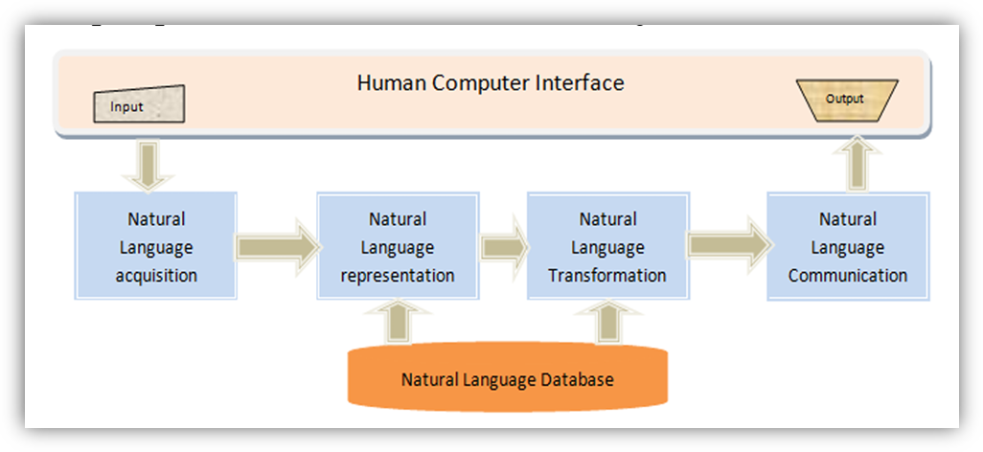

Post-processing steps may be applied to refine model results using the Natural Language Generation (NLG), addressing any ambiguities or coherence issues in generated text. Once trained and evaluated, the NLP model is ready for deployment in real-world applications, such as software, chatbots, or systems requiring natural language understanding or generation. Finally, the NLP workflow is a dynamic process, often involving continuous improvement efforts to refine models based on new data, feedback, and evolving language patterns, ensuring sustained effectiveness across diverse applications**.**

In conclusion, the NLP workflow serves as a comprehensive and iterative process designed to empower machines with a nuanced understanding of human language. The incorporation of post-processing steps enhances the precision and clarity of model-generated text, addressing ambiguities and coherence issues. Once the NLP model undergoes training and evaluation, it emerges as a potent tool for deployment across various real-world applications, ranging from sophisticated software solutions to interactive chatbots. However, the dynamism of language requires that the NLP workflow remains adaptable and open to continuous improvement. Ongoing efforts to refine models based on new data, user feedback, and evolving language patterns are crucial, ensuring that NLP applications evolve in tandem with the ever-changing landscape of human communication. Through this cyclical process of enhancement, the NLP workflow stands as a pivotal force in advancing the capabilities of artificial intelligence in understanding and generating natural language.

.

**PROPOSED WORK**

In response to the dynamic nature of human communication, this proposed work seeks to elevate Natural Language Processing (NLP) by integrating cutting-edge Adaptive Dialogue Systems (ADS). The primary objective is to create a more responsive system capable of not only deciphering intricate language nuances but also adapting in real-time to the evolving context of human conversations.

The core focus of this endeavor involves the development of advanced Adaptive Dialogue Models. These models will be meticulously designed and implemented to possess the agility needed for dynamic response adjustments. By leveraging state-of-the-art machine learning techniques, the proposed dialogue models will dynamically adapt their responses based on user inputs, ensuring a more fluid and contextually relevant interaction.

A critical aspect of the proposed work lies in enhancing context awareness within the dialogue systems. This entails the integration of advanced mechanisms to provide a profound understanding of ongoing conversations. By imbuing the system with a heightened awareness of context, the aim is to foster more coherent and meaningful responses, effectively addressing the challenges posed by the fluid and evolving nature of human communication.

Furthermore, the proposed work will focus on optimizing Intent Recognition mechanisms. Understanding user intent is pivotal for effective communication. Through advanced machine learning algorithms, the dialogue system will be trained to discern subtle variations in user intent, enabling it to provide responses that are not only contextually appropriate but also aligned with the user's underlying goals.

In conclusion, this proposed work envisions a significant advancement in the synergy between NLP and Adaptive Dialogue Systems. By pushing the boundaries of adaptability and context awareness, the goal is to create a more sophisticated and responsive system that mirrors the richness of natural conversation, thereby enhancing the overall user experience in human-machine interactions.

**PROPOSED METHODLOGY**

In response to the evolving dynamics of human-machine interactions, this proposed work envisions an advancement in Adaptive Dialogue Systems (ADS) by seamlessly integrating them into the broader workflow of Natural Language Processing (NLP). The primary objective is to create a symbiotic relationship between ADS and NLP, fostering a more dynamic and contextually aware system for interpreting and generating human-like language.

The workflow commences with User Input Analysis, where advanced algorithms like natural language Understanding (NLU) analyze user inputs using NLP techniques. This phase considers not only explicit content but also factors such as tone, sentiment, and linguistic nuances. The integration of NLP in user input analysis lays a robust foundation for understanding the intricacies of language and user intent.

Following this, the workflow seamlessly transitions into Dialogue Manager, where the Adaptive Dialogue System leverages NLP to capture and retain information from past interactions. This integration ensures that the system maintains a contextual memory bank, enhancing its ability to comprehend and respond coherently to users based on historical context.

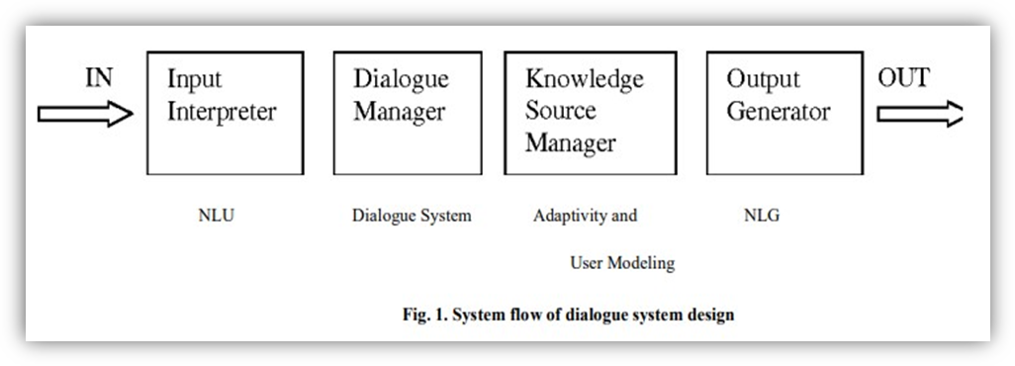

The subsequent phase involves Dynamic Response Generation by analyzing tons of information in the Knowledge Source Manager Natural Language Generation (NLG) generates response accordingly, The Adaptive Dialogue System utilizes advanced NLP techniques to understand the user's input in context, enabling it to dynamically adjust responses based on evolving conversation dynamics and user preferences.

As an integral part of the workflow, User Feedback Loop Integration incorporates NLP-driven sentiment analysis and feedback processing. This allows the system to not only adapt its responses but also continuously learn and refine its understanding of user preferences through NLP-driven analysis of user feedback.

In conclusion, the proposed workflow seamlessly integrates Adaptive Dialogue Systems with Natural Language Processing, creating a holistic approach to human-machine interactions. The synergy between ADS and NLP enhances the system's ability to comprehend and generate language, fostering a more adaptive, intuitive, and user-centric dialogue model for a wide array of applications.

**DIFFERENCES BETWEEN NLP AND NLP WITH ADAPTIVE DIALOGUE SYSTEM**

|  |  |
| --- | --- |
| **NLP (Natural Language Processing)** | **NLP-ADS (Natural Language Processing with Adaptive Dialogue Systems)** |
| NLP primarily focuses on developing algorithms for machines to understand, interpret, and generate human language. | NLP-ADS extends beyond traditional NLP by incorporating adaptive dialogue systems, emphasizing interactive and dynamic conversational capabilities. |
| NLP deals with processing and understanding static text or speech rather than dynamic and adaptive conversations. | NLP-ADS emphasizes the ability to engage in dynamic and adaptive conversations, responding contextually to user input over the course of a dialogue. |
| Context handling in NLP is typically confined to individual sentences or documents. | NLP-ADS focuses on managing and adapting to dynamic context within a conversation, considering the evolving nature of dialogue. |
| NLP is designed for one-off tasks or queries, often focused on extracting information or performing specific functions based on a single input. | NLP-ADS aims to create more engaging and natural interactions by considering the conversational context and adapting responses accordingly. |
| NLP often relies on pre-trained models or static algorithms without a strong emphasis on learning and adapting based on user interactions. | It incorporates adaptive elements that can learn and evolve based on user interactions, allowing for a more personalized and context-aware dialogue experience. |

**APPLICATIONS OF NLP WITH ADS**

1. **Interactive Customer Support:**

* NLP-ADS is utilized in customer support systems to provide interactive and adaptive assistance. These systems can understand and respond to customer queries in a dynamic conversational context, improving the overall customer experience.

1. **Personalized Virtual Assistants:**

* NLP-ADS enables the development of virtual assistants that can adapt to user preferences, learn from interactions, and provide personalized responses. This is valuable for creating more engaging and user-centric virtual assistant experience.

1. **Educational Chatbots:**

* In educational settings, NLP-ADS can be applied to develop chatbots that engage with students in natural language, providing personalized feedback, answering questions, and adapting to individual learning styles.

1. **Healthcare Conversational Agents:**

* NLP-ADS is employed in healthcare applications to create conversational agents that can interact with patients, answer health-related queries, and provide support. These systems can adapt to changes in a patient's condition and offer dynamic assistance over time.

**LIMITATIONS**

1. Ambiguity and Contextual Understanding:

* Challenges in accurately interpreting ambiguous language, contextual subtleties, and implied meanings, leading to potential misinterpretations in complex conversations.

1. User Intent Recognition:

* Limitations in precisely identifying diverse user intents, particularly in cases where intent may be implicit or expressed through nuanced language, impacting the system's ability to provide targeted responses.

1. Data Privacy and Ethical Concerns:

* Issues related to the privacy of user data, ethical considerations in handling sensitive information, and the potential for unintended biases in language processing algorithms.

1. Scalability and Resource Intensiveness:

* Challenges in scaling adaptive dialogue systems to handle a large volume of users simultaneously, along with resource-intensive training requirements for complex NLP models.

1. Real-time Adaptation and Learning:

* Difficulties in achieving real-time adaptation and learning, especially in highly dynamic conversational contexts, where the system may struggle to keep pace with rapidly evolving user inputs and preferences.

**FUTURE SCOPE**

NLP with Adaptive Dialogue System unfolds exciting possibilities for future enhancements in this domain. Continued research and development are essential to overcome current limitations, such as improving ambiguity handling, refining user intent recognition, and addressing privacy concerns. Future enhancements may also delve into the ethical dimensions of these systems, ensuring fairness, transparency, and accountability in their deployment. Furthermore, exploring more efficient and scalable architectures, harnessing the power of emerging technologies like quantum computing, and advancing real-time adaptation capabilities will be pivotal for the continued evolution of NLP with Adaptive Dialogue Systems.

As we look ahead, the convergence of NLP and adaptive dialogue systems stands as a beacon in the broader landscape of artificial intelligence. The vision is not just about building systems that understand language; it is about crafting systems that empathize, learn, and evolve in tandem with the ever-changing patterns of human communication. The future holds exciting prospects for these technologies, not only in refining user experience but also in unlocking new frontiers of applications across industries. As researchers, developers, and practitioners collaborate on this transformative journey, the realm of NLP with Adaptive Dialogue Systems is poised to play an increasingly integral role in shaping the future of human-machine interactions.

**CONCLUSION**

The integration of Natural Language Processing (NLP) with Adaptive Dialogue Systems marks a significant stride toward creating more intuitive and responsive human-machine interactions. The synergy between NLP and adaptive dialogue models has addressed longstanding challenges in language understanding and response generation. The proposed workflow, incorporating advanced algorithms, contextual memory mechanisms, and dynamic response generation, lays the groundwork for systems that comprehend the subtleties of human language and adapt dynamically to evolving contexts. Despite current limitations, this intersection of NLP and adaptive dialogue systems holds immense promise in reshaping how machines understand, interpret, and respond to human communication.

**REFERENCES**

[1] Pontus Wärnestål (2008). NLP Techniques for Adaptive Dialogue Systems. In: Halmstad University.

[2] Elizabeth D. Liddy (2001). Natural Language processing. In: Syracuse University.

[3] Santosh Behera and Mitali Nayak (2020). Natural Language Processing for Text and Speech Processing: A Review Paper In: Dedicated

Freight corridor corporation Ltd.

[4] Moneerh Aleedy1 & Hadil Shaiba2 (2019). Generating and Analyzing Chatbot Responses using Natural Language Processing. In: School of Computing, Dublin City University, Dublin, Ireland

[5] https://www.techtarget.com/searchenterpriseai/definition/natural-language-processing-NLP.

[6] https://www.javatpoint.com/nlp.